**BUS STOP WITH A BRAIN**

**Circuit diagram:**

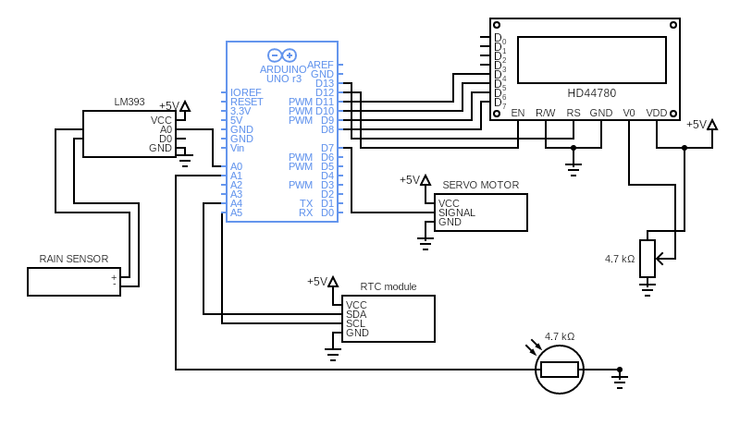

**Working of components**

**Arduino UNO Board:**

The user can get started by connecting the Uno to a computer with the USB cable or by powering it with an AC / DC adapter or battery. The Uno can be programmed with Arduino Software (Integrated Development Environment). Arduino Uno features 14 digital input / output pins (six of which can be used as PWM outputs), six analog inputs, and a 16MHz quartz crystal. Uno also includes a USB connection, a power jack, an In- Circuit Serial Programming (ICSP) header, and a reset button. This Arduino MCU board contains everything the user needs to support the MCU.

**Servo Motor:**

The servo motor is connected to the D8 pin of Arduino. A servo consists of a Motor (DC or AC), a potentiometer, gear assembly, and a controlling circuit. First of all, we use gear assembly to reduce RPM and to increase torque of the motor. Say at initial position of servo motor shaft, the position of the potentiometer knob is such that there is no electrical signal generated at the output port of the potentiometer. Now an electrical signal is given to another input terminal of the error detector amplifier. Now the difference between these two signals, one comes from the potentiometer and another comes from other sources, will be processed in a feedback mechanism and output will be provided in terms of error signal. This error signal acts as the input for motor and motor starts rotating. Now motor shaft is connected with the potentiometer and as the motor rotates so the potentiometer and it will generate a signal. So as the potentiometer’s angular position changes, its output feedback signal changes. After sometime the position of potentiometer reaches at a position that the output of potentiometer is same as external signal provided. At this condition, there will be no output signal from the amplifier to the motor input as there is no difference between external applied signal and the signal generated at potentiometer, and in this situation motor stops rotating.

**DS3231 RTC:**

The DS3231 is a low-cost, extremely accurate I2Creal-time clock (RTC) with an integrated temperature-compensated crystal oscillator (TCXO) and crystal. The device incorporates a battery input, and maintains accurate timekeeping when main power to the device is interrupted. The integration of the crystal resonator enhances the long-term accuracy of the device as well as reduces the piece-part count in a manufacturing line. The DS3231 is available in commercial and industrial temperature ranges, and is offered in a 16-pin, 300-mil SO package. The RTC maintains seconds, minutes, hours, day, date, month, and year information. The date at the end of the month is automatically adjusted for months with fewer than 31 days, including corrections for leap year. The clock operates in either the 24-hour or 12-hour format with an AM/PM indicator. Two programmable time-of-day alarms and a programmable square-wave output are provided. Address and data are transferred serially through an I2C bidirectional bus. A precision temperature-compensated voltage reference and comparator circuit monitors the status of VCC to detect power failures, to provide a reset output, and to automatically switch to the backup supply when necessary.

**16x2 LCD:**

The LCD module is in connection with D8 to D13 pins of Arduino. An LCD (Liquid Crystal Display) screen is an electronic display module and has a wide range of applications. A 16x2 LCD display is very basic module and is very commonly used in various devices and circuits. A 16x2 LCD means it can display 16 characters per line and there are 2 such lines. In this LCD each character is displayed in 5x7 pixel matrix. The 16 x 2 intelligent alphanumeric dot matrix display is capable of displaying 224 different characters and symbols. This LCD has two registers, namely, Command and Data.

Command registers stores various commands given to the display. Data register stores data to be displayed. The process of controlling the display involves putting the data that form the image of what you want to display into the data registers, then putting instructions in the instruction register. In your Arduino project Liquid Crystal Library simplifies this for you so you don't need to know the low-level instructions. Contrast of the display can be adjusted by adjusting the potentiometer to be connected across VEE pin.

**Rain sensing pad:**

Normally under dry conditions, the sensing pad provides high resistance and low conductive. So, the 5v power supply cannot be passed from one track to another track. Its resistance varies according to the amount of water on the surface of the sensing pad. When water drops fall on the sensor pad surface its resistance will decrease and conductivity will increase. So, when water drops increase on the pad surface it can pass more power supply through one track to another track.

**LM393 Module:**

When water drops increase on the sensing pad surface then its conductivity will increase and also resistance will decrease. Then a Low amount of voltage from the sensing pad is given to the Inverting input (2) of the IC. Then the LM393 IC compares this voltage with the threshold voltage. In this condition, this input voltage is less than the threshold voltage, so the sensor output goes LOW (0).

When no water drops fall on the sensing pad surface then it has low conductivity and high resistance. Then the high amount of voltage will be allocated across the sensing pad. So, a High amount of voltage from the sensing pad is given to the Inverting input (2) of the IC. Again, the LM393 IC compares this voltage with the threshold voltage. In this condition, this input voltage is greater than the threshold voltage, so the sensor module output goes High (1).

**Light Dependent Resistor (LDR):**

The LDR is connected to the A3 pin of Arduino. This resistor works on the principle of photo conductivity. It is nothing but, when the light falls on its surface, then the material conductivity reduces and also the electrons in the valence band of the device are excited to the conduction band. These photons in the incident light must have energy greater than the band gap of the semiconductor material. This makes the electrons to jump from the valence band to conduction.

These devices depend on the light, when light falls on the LDR then the resistance decreases, and increases in the dark. When a LDR is kept in the dark place, its resistance is high and, when the LDR is kept in the light its resistance will decrease.

If a constant “V’ is applied to the LDR, the intensity of the light increased and current increases. The figure below shows the curve between resistance Vs illumination curve for a particular light dependent resistor.